**Modes of python:**

We can execute python programs in two modes:

1)Interactive mode:

Type text into python prompt

>>> print "hello"

Output: hello

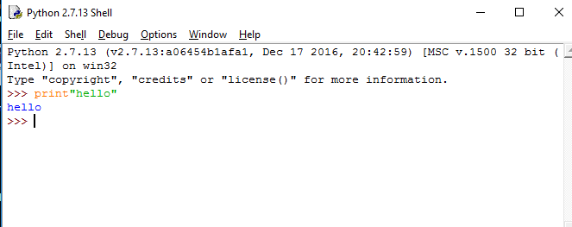

2) Script mode:

Write code into script and save with **.py** extension and run that file

>>>print “hello”

Now save this file firstcode.py and run it.

Saved file:

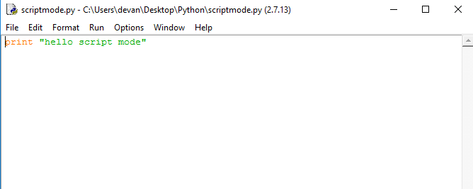

Run file:

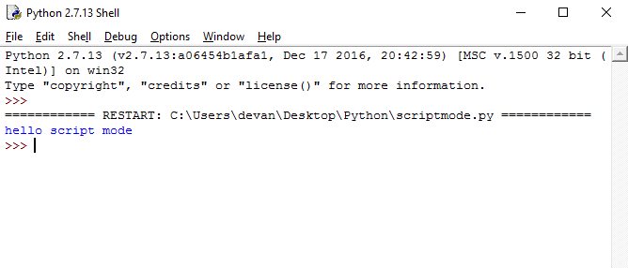

**Python Identifiers:**

A Python identifier is a name used to identify a variable, function, class, module or other object. An identifier starts with a letter A to Z or a to z or an underscore (_) followed by zero or more letters, underscores and digits (0 to 9).

Python does not allow punctuation characters such as @, $, and % within identifiers. Python is a case sensitive programming language. Thus, **Abc** and **abc** are two different identifiers in Python.

Here are naming conventions for Python identifiers −

* Class names start with an uppercase letter. All other identifiers start with a lowercase letter.
* Starting an identifier with a single leading underscore indicates that the identifier is private.
* Starting an identifier with two leading underscores indicates a strongly private identifier.
* If the identifier also ends with two trailing underscores, the identifier is a language-defined special name.

**Python keywords:**

|  |  |  |
| --- | --- | --- |
| and | exec | not |
| assert | finally | or |
| break | for | pass |
| class | from | print |
| continue | global | raise |
| def | if | return |
| del | import | try |
| elif | in | while |
| else | is | with |
| except | lambda | yield |